Modern Art: Rules
Modern Art, the world of art, young talent suddenly explodes onto the scene, new trends come and go, but whose reputation will last?, which will be tomorrow's masterpieces? Is it Art or Kitsch, that is the question. This game consists of four Auctions or rounds, in each, works by up to 5 Artists will be offered for sale and auctioned off in various ways. In Modern Art, the players take on the roles of art dealers who simultaneously are art collectors. It is their decision which artworks to sell, and how to sell them. Successful players must balance two aims. They must collect the best artworks for their own collections and forward the careers of those artists from whom they have most to gain and at the same time they must raise as much money as possible by successfully auctioning off those works that don't fit their own strategy and pick up their own favourites as cheaply as possible.
Dreams of fame and riches, but dreams can vanish in an instant, leaving the player with a gallery full of last year's art, unwanted and valueless. Only those with a nose for tomorrow's tastes today, will rise to the top of the Art world.

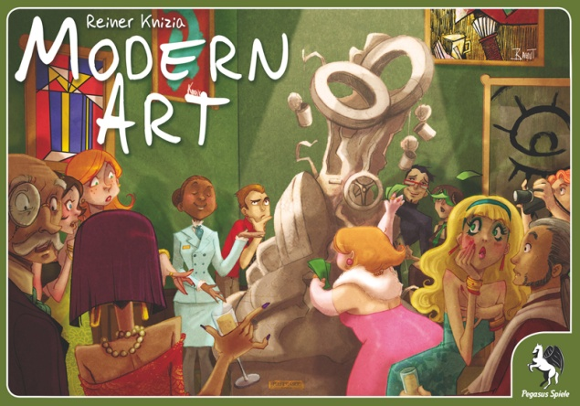
Contents
- 1 board for value tracking
- 70 cards with artworks from 5 artists
- 5 sightscreens
- 93 coins in various denominations
- 12 value chips
- 1 rulebook

Preparation
Before the first game, the coins and chips must be carefully removed from their backing sheet. The board is laid in the centre of the table so as to be visible to all players. It is used to show the five artists and helps with sorting out the results of each round. Each player takes 100 in starting capital plus a sightscreen which he should put up in front of him so as to prevent the other players from seeing how much money he has at any point. The rest of the money makes up the Bank, and should be given to one of the players who acts as Banker for the game. The 70 art cards are well shuffled and dealt out to the players. With 3 players each receives 10 cards, with 4 players, each gets 9 cards, and with 5, 8 cards. The rest of the cards are put face down near the board ready for later rounds.

Play and Object of Game
A game of Modern Art consists of four rounds; each round involves several separate sales of cards (representing works of art). After each of the four rounds, there is a general settling up of earnings. Players can make money in two ways. Firstly they earn cash by successfully auctioning off Works of Art from their own stocks. Secondly, at the end of the round, all the cards sold in the round are cashed in, but only those which have sold best have any value. The winner is the player who has most money at the end of the game.
The First round. We will use a group of 4 players, Axel, Beatrix, Clemens and Doris, as examples to illustrate the game. All the rounds are played in the same way, so the following applies to all 4 rounds. The youngest player, in this case Axel, starts. He chooses a card from his hand and lays it face up in the middle of the table. This card is now up for auction. As in reality there are various methods of auction. The method used in each case is indicated by the symbol on the card.

Euro signs in talk bubbles indicates a free auction. This means that all players can bid, there is no order of bidding and bids can be raised as players wish. So, for example, if Axel plays a card with Euro signs on it, then Doris could start with a bid of 14, Clemens tops her with 15, Doris replies with 17, Axel bids 18 and Doris then 19. Axel, as the auctioneer for this card tries to get a better bid but fails, giving Doris the card for 19. She takes the card and places it face up in front of her, then she pays the money to Axel (Diagram 1). Now it is the turn of Beatrix to play a card.

She plays a card with Euros in a circle on it. This means that each player in turn, starting with the player to the auctioneer's left, makes a bid. The auction continues back to the auctioneer who has the last bid. In this case, Clemens starts, with a bid of 8, Doris passes, Axel bids 12 and Beatrix takes the card with a bid of 13. Because she has bought her own card, she doesn't pay any of the other players, but instead gives the 13 to the Bank.

Now it is Clemens' turn and he lays down a card with a Euro in a fist on it. This means that the card is auctioned using secret bids. In practice, each player decides how much he wants to bid and picks up that amount of coins. All players put their closed fists over the card and when all are ready, they open their hands and reveal their bid.
In this case, Clemens has 11 in his hand, Doris 12, Axel 12 too and Beatrix nothing. The highest bids have come from Doris and Axel. Where two or more players tie with the highest bid, the card goes to the one who is first in line, starting with the auctioneer and moving clockwise. Thus in this example, Clemens is auctioneer, but isn't one of the highest bidders, so Doris as next in line gets the card. Had Axel tied with Beatrix, he would have got the card, but Doris wins, so she pays 12 to Clemens and takes the card laying it down face up in front of her.

Doris plays the next card and it has a Euro sign on a sign-post. Here the Auctioneer sets a price for the card. Each player in turn is offered the card at this price and may accept or decline. If all players decline then the Auctioneer must buy the card at the price they have set. (Notice that the auctioneer may not set a price higher than their cash holding.) In this case, Doris sets the price at 14. Axel isn't interested at that price so he passes, but Beatrix accepts the card, pays 14 to Doris and puts the card down face up in front of her.

It is Axel's turn again and he lays down a card with a card plus card symbol on it. He then lays down another card by the same artist but this time with "Euro signs in talk bubbles". Cards with the "card plus card" symbol are played in conjunction with another card of the same artist but with a different symbol. If the player who played the "c+c" card cannot or don't want to play another card in conjunction, the next player to his left might add a card to the "c+c" card and then auctions off the two cards in the normal way, as per the symbol on the second card. If no player can or want to "follow suit", then the player who originally played the card gets the card back and puts it face up in front of him without paying anything. Whoever adds the second card to the "c+c" card auctions off both cards as one lot and is then followed in turn by the player to his left (players who have not added a card effectively lose a turn). Note that the player who adds the second card and auctions both cards receives all of the proceeds from their sale. The money is not split between the initial player and the player of the second card as some translations have stated.
So, Axel has laid two cards by the same artist, one with a "card plus card" symbol and one with a "Euro signs in talk bubbles" symbol. He now auctions both cards as one lot, using the symbol from the second card to decide the type of auction, in this case a free auction with no fixed prices or order.
Clemens bids 26, Beatrix 27 and so it goes on until Clemens makes the highest bid with 33. Clemens takes both cards, lays them both down face up in front of him and pays Axel 33. Notice that the price reflects the fact that two cards have been auctioned rather than one. In our examples players have now used all the available types of card, but the round isn't over until there are 5 cards from one artist on the table. Let's see how it continues.
Beatrix thinks that what Axel can do, she can do better so she too lays down a "c+c" card from an artist along with another card by the same artist with the "euro in the fist" symbol. Both cards are therefore auctioned off as one lot, using a secret bid system (players put as much money as they wish to bid into their fist and all reveal simultaneously how much they have bid). Beatrix shows 22, Clemens 22, Doris 33and Axel 16. Doris therefore takes the two cards and pays Beatrix 33, not very pleased at having paid so much when a bid of 23 would have been enough but then, that is the problem with secret bids.
Clemens now takes his turn and he plays another card by the same artist. Since this is the 5th card by the same artist on the table, the round ends immediately. The 5th card is not auctioned off nor is it sold at the end of the round. Its only function is to increase the number of cards of that type on the table to five and so to end the round.

Settling Up
The first thing to decide is which artist's works have sold best in this round. All cards on the table, including the last one played, are counted towards the totals. The artist with the most cards gets a 30 marker placed on the board under his name in the uppermost of the 4 auction rows. The second artist gets a 20 put under his name. In the case of draws, the type which lies furthest to the left on the board wins. The third artist gets at a 10 marker is placed under his or her name. The works of the remaining two artists have no value. Now that the value of each card has been established, the players sell off their cards. Valueless cards are laid to the side.
Axel hasn't got any cards to sell, so his cash stays at 152, Beatrix receives 30 for one artist and 10 for her another, giving her a total of 144. Clemen's total is 139 (79 cash plus 60 for 2 cards worth 30). Doris has 3 cards to sell but only totals 122. Once all players have taken the cash for their pictures, the cards played in the first round are returned to the box, they play no further part in the game.

The Second and subsequent rounds
While the first round is being played, the players get no extra cards. Now however, before the second round, and again before the third round, additional cards are dealt, the number depends on the number of players.
Number of cards 1st round 2nd Round 3rd Round 4th Round
3 Players 10 6 6 0
4 Players 9 4 4 0
5 Players 8 3 3 0
No new cards are dealt before the fourth round. Play in subsequent rounds commences with the player to the left of the player who laid out the last card in the previous round.
The second, third and fourth rounds are played in exactly the same way as the first. But the game isn't simply a repetition of the first round. The value of cards can continue to rise cumulatively through the game. As we have seen in the first round, the exact value of each card is only really decided at the end of the round. In the same way, the true value of a card, i.e. whether its value will increase or plummet, can only really be determined at the end of each round. So we need to look at how the values at the end of the second, third and fourth rounds are reckoned.
There are three points that need to be taken into consideration.
1) The results of the individual round is reckoned exactly as per the first round, a 30 marker is placed under the name of the most successful artist (the one with 5 cards on the table) in the relevant row for that round. A 20 marker goes under the second most successful artist's sign and 10 under the third most successful. The other two artists' works have no value.
2) Now it can be seen from the board, which, if any, of the successful artists have also been successful in previous rounds, i.e. whether any markers are already in that column.
3) If any of the successful artists from this round do have markers from previous rounds then the value of the artist's works is the sum of all the markers.

Settling up after the second and third rounds
We can skip the actual play of the cards in the second round so we can go straight to the summing up. Let's assume that at the end of the second round, there are 5 Sadland cards on the table, 4 Koriko, 3 Nex, 1 Darmoir and 1 Bahut. Obviously the last card played was the 5th Sadland. Now we can work it all out with reference to the three points from above.
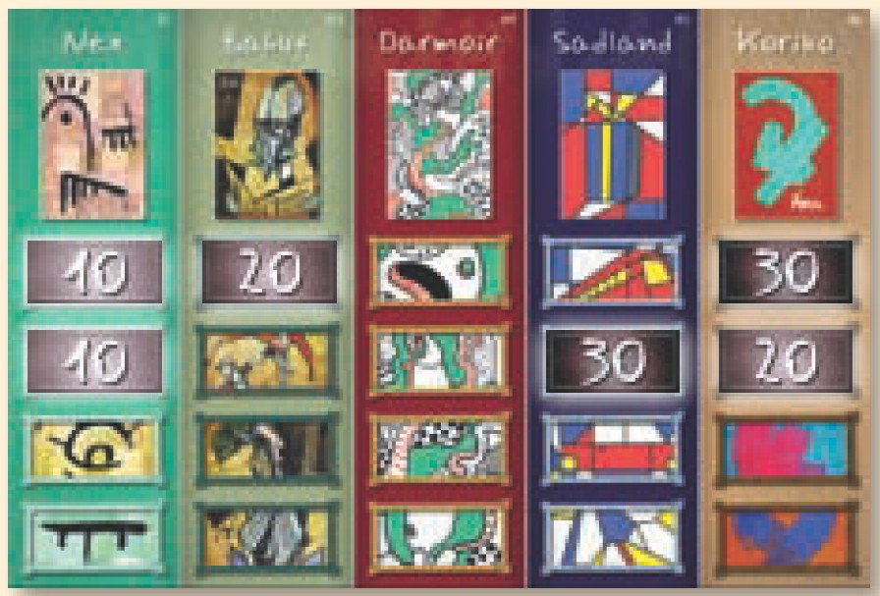
1) Which artists have been most successful? Well, there are 5 Sadland on the table, so that is obviously in first place, and the 30 marker is placed in the Sadland column on the board in the row for the 2nd round (season). 2nd is Koriko so the 20 marker goes in the Koriko column and 3rd is Nex so the 10 marker goes down under Nex.
2) Which of these three have been successful in a previous round? Koriko was 1st in the first round, so there is already a 30 marker in that column and Nex was 3rd and has a 10 marker under it.
3) What then are the final prices as shown by the sums of the markers? Nex = 10 + 10 = 20 per card on the table; Sadland = 0 + 30 = 30 per card on the table (except the 5th played which is not auctioned); Koriko = 30 + 20 = 50 per card on the table.
The 20 marker for Bahut is not counted at this point, since Bahut wasn't one of the three successful artists in this round. If, however, Bahut received a marker in a later round, then the 20 would be added to it.
Now the players cash in their cards as they did at the end of the first round. The cards on the table are returned to the box, and new cards are dealt ready for Round 3. Rounds 3 and 4 are carried out in exactly the same way. At the end of Round 4, the player with the largest amount of cash wins. Any cards left in players' hands at the end of Round 4 are worthless.

A few special situations which may occur in the game
Ending a round with a double auction card

Let us suppose that during a round, 3 "Koriko" cards have already been played. A player now plays a "Koriko" card with a symbol. He may play, or if he can't, one of the other players, may now play a second "Koriko" card to go with the first. As soon as this is done, there are 5 "Koriko" cards on the table. The round ends immediately, the two cards are not auctioned and are not sold.
An early end to the game
It can rarely happen that a game never reaches the end of the fourth round, because all the players have already played all their cards without there being five from any one artist on the table. In this case the game ends after the play of the last card, but before that card is auctioned. The artist with most examples on the table is valued at 30, the second best 20 and so on as usual. The last card played is not sold, but does count towards the number of the artworks on the table from that particular artist.
Equal numbers of cards
As already said, if two or more artists have equal numbers of artworks on the table, the artist lying furthest to the left on the value tracking board wins. For example Nex has precedence over Bahut, Darmoir over Sadland. To balance this inequality, there are unequal artworks from the various artists. There are 12 Nex, 13 Bahut, 14 Darmoir, 15 Sadland and 16 Koriko. It does not follow therefore that Nex will score more often than Koriko, since its advantage in position is balanced by its disadvantage in terms of card numbers.
No Bids at Auction
If no one makes a bid at auction the card is taken by the auctioneer without payment.
All cards played
If one or more players run out of cards during a round, they merely miss their turn. Obviously, they may still bid for cards played by other players.

Variant for Three Players
For those who believe that in a three-player game, each player has too much influence over the final outcome, we offer this variant:
At the beginning of the game, and after every auction round, four sets of cards are dealt according to the table in the rules. (As if there were four people playing.) The fourth set of cards is left face-down to the side. These cards represent a non-playing fourth player – whom we like to call an overzealous Japanese art collector.
In the course of an auction round, the player who wins the bidding may turn over the top card of the virtual player. These cards may be revealed as long as they last, and once all of the cards of this Japanese are revealed, there will be no more to turn over. The decision, whether to turn one of these cards over, depends only upon the tactical considerations of the player who won the bidding on a card (or cards).
The displayed card, of this overzealous person from the Far East, is neither auctioned nor does it bring in money at the end of an auction round. These cards serve only to influence the number of played cards for each artist. For example: by turning over a card, the fifth one from an artist may be revealed, thus ending that auction round. These cards count towards an artist's worth at the end of an auction round. (They count towards the number of an artist's cards bought during that round for final determination of whether that artist's paintings are worth 30, 20, or 10.) Once the players' cards have been cashed in, all cards on the table, including those from the Japanese art collector, are removed from play.
If a Double auction card is revealed when turning over the top card of this virtual player, a second card must not be played.

Some Hints on Play
At first play, there is a lot in Modern Art that is new; which card should one play? Which types of auction work best at which points in the game? Perhaps the hardest aspect of the game for beginners is to judge what is the "right" price for the cards. Obviously, there is no set rule for this, but there are a couple of points which should be kept in mind.
The maximum value that a card can attain in the first round is 30. Second place will be worth 20 and third 10. If then a card goes for 22 at auction, the player buying it must ensure that that artwork will be from the first place artist or he automatically makes a loss on that card. Players should be prepared to drop out of auctions, rather than pay unrealistic prices.
In the second and later rounds, cards that have already got markers against them, become more valuable, but only if they are in the first three again in the actual round. An artist who has been second in the first round, can reach a value of 50 in the second, but you should never forget the word "can".
Basically, the rule at auction is to keep in mind both what value the card is capable of reaching and also what it's chances are of reaching that value.

